### 

### **Product Requirements Document (PRD)**

### **One store on XC can be assigned to Multiple Store leads**

**Prepared by:** Anzala Syed

**Prepared For:** Hamed

### **Product Requirements Document (PRD)**

**Title:** Concurrent Data Access and Confidentiality for Store Leads

**Problem Statement:** In current application, one store can be assigned to only one store lead on XC which is causing significant issues related to data access, confidentiality, and accountability for store leads as other store leads have to use the credentials of the same store lead. In GEC we need the functionality in which one store can be assigned to more than one store leads so that they can add the orders for same store with their own credentials

### **Issues**

1. **Concurrency Limitation:**
   * The current application restricts multiple store leads from adding orders simultaneously for the same store, causing productivity issues and delays.
2. **Data Confidentiality:**
   * Data added by one store lead is visible to other store leads of the same store as all the store leads, which breaches confidentiality requirements.
3. **Credential Sharing:**
   * Other store leads have to use the credentials of the only store lead to whom the store assigned in order to add their orders or, leading to security and accountability issues.
4. **Manager Evaluation:**
   * During interstore movement evaluations, the same name is displayed for all store leads because they use shared credentials. This results in inaccuracies in assessing the progress and performance of individual store leads, creating challenges in evaluating contributions fairly and effectively.

**Objective:** Enable multiple store leads to concurrently add data for the same store in the application without conflicts or blocking. Ensure that data added by each store lead remains confidential and is not visible to other store leads of the same store.

### **Requirements(Goals to achieve)**

#### **1. Functional Requirements**

**1.1 Concurrency Control:**

* Allow multiple store leads to add data concurrently without conflicts or blocking.

**1.2 Data Confidentiality:**

* Ensure the order added by each store lead is only accessible to the store lead who added it.
* Implement role-based access control to manage permissions and data visibility.

**1.3 Unique Credentials:**

* Each store lead should have their own credentials to log in and add data.
* Eliminate the need for credential sharing among store leads to access same store

**1.4 Accurate Attribution:**

* Ensure the system accurately records and displays which store lead added each product or order.
* Provide managers with detailed reports showing individual contributions from each store lead.

**1.5 Evaluation in Interstore Movement:**

* Modify the table in interstore movements to accurately reflect the contributions of each store lead, ensuring fair and effective performance assessments.

**1.6 Error Handling:**

* Provide meaningful error messages to users when conflicts occur, with options to retry or refresh data.

**1.7 Data Integrity:**

* Ensure all data operations maintain the integrity and consistency of the store data.
* Prevent data corruption or loss during concurrent operations.

#### **2. Non-Functional Requirements**

**2.1 Performance:**

* Optimize the application to handle concurrent data operations efficiently.

**2.2 Scalability:**

* Design the solution to support a growing number of store leads and stores without significant performance degradation.

**2.3 Usability:**

* Ensure the user interface remains responsive and user-friendly.
* Provide clear instructions and feedback to users when resolving conflicts.

### **Testing and Validation**

**1. Unit Testing:**

* Cover scenarios of concurrent data access, conflict resolution, data confidentiality, and accurate attribution.

**2. Integration Testing:**

* Test the entire workflow with multiple store leads adding data concurrently.
* Validate that data integrity is maintained, conflicts are handled gracefully, and data confidentiality is ensured.
* Confirm that managers can see accurate attributions for each store lead.

**3. Performance Testing:**

* Ensure the application performs well under load with concurrent users.

### **Documentation and Training**

**1. User Guide:**

* Explain the new concurrency handling, data confidentiality mechanisms, and the process for logging in with unique credentials.
* Provide instructions on how to resolve conflicts and view accurate attributions.

**2. Developer Documentation:**

* Provide technical documentation on the changes made, including configuration settings.

### 

**Screen Shots:**

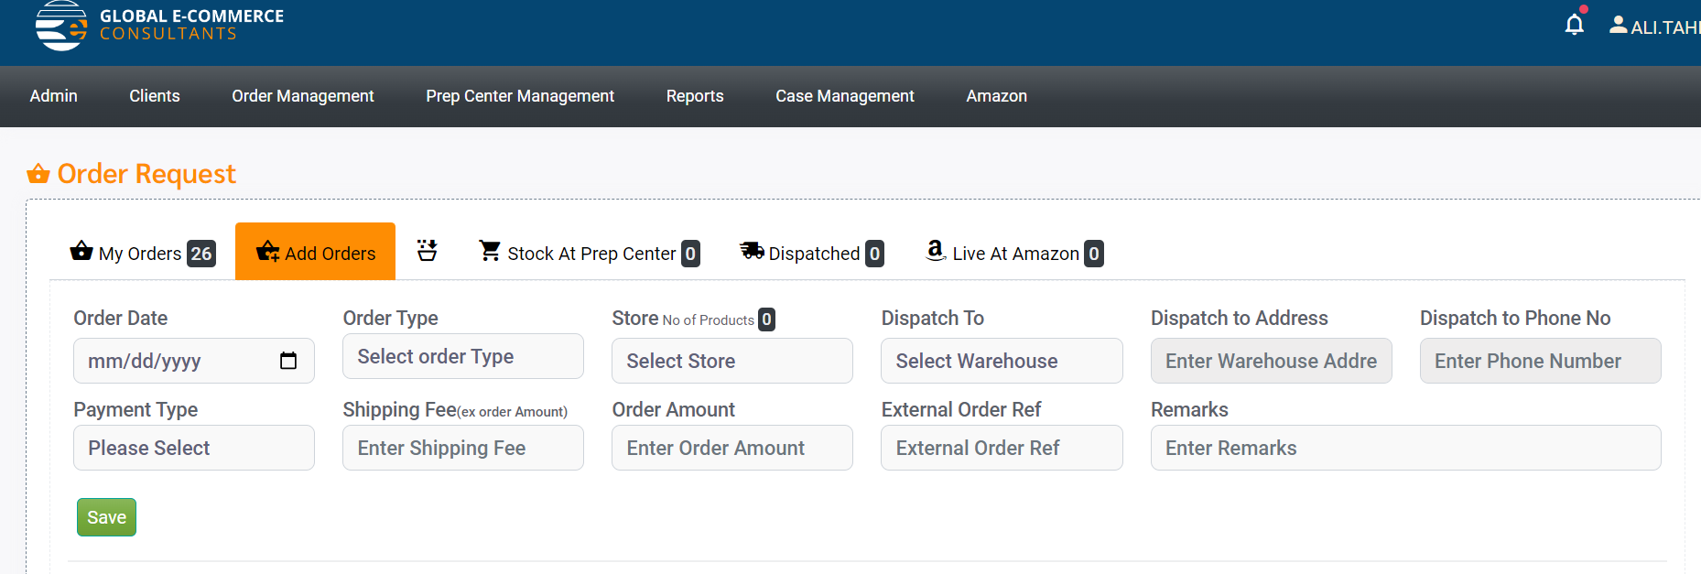

* when the product hunting is done the store lead add the order ,this is where the problem arises because all the store leads have to login with the credentials of the one store lead to which the store is assigned

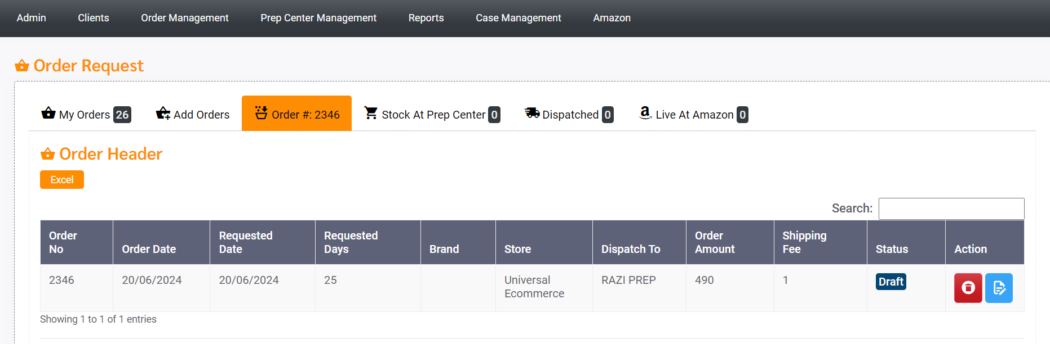

* There must be a column to show that which store lead added the order

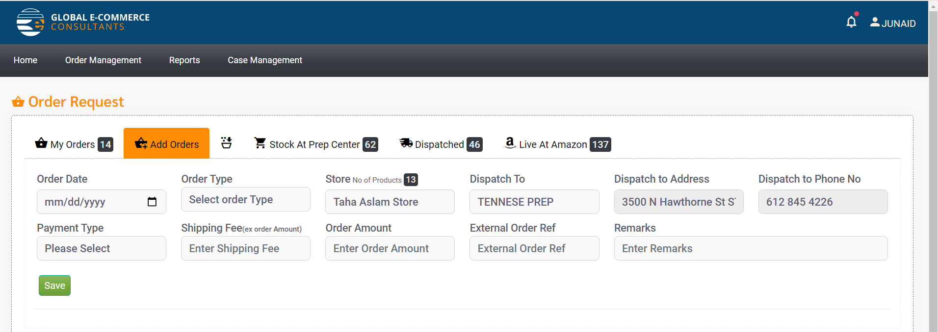

* Now junaid is the store lead so he can view the stores and select the stores in this dropdown
* We need this functionality for multiple store leads to which the same store is assigned

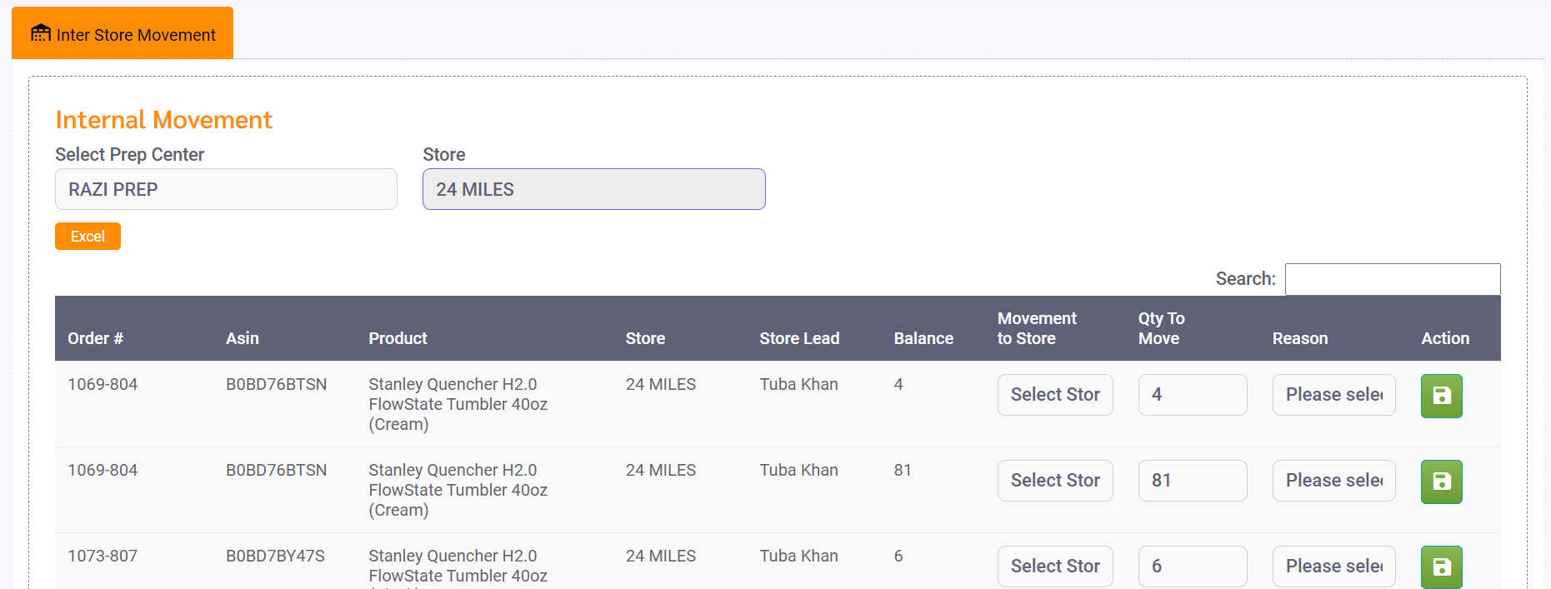

* In inter store movement when it comes to evaluation same name is displayed for the store leads as all the store leads uses the same login id to enter the orders and this causes serious issues in evaluating the progress of multiple store leads

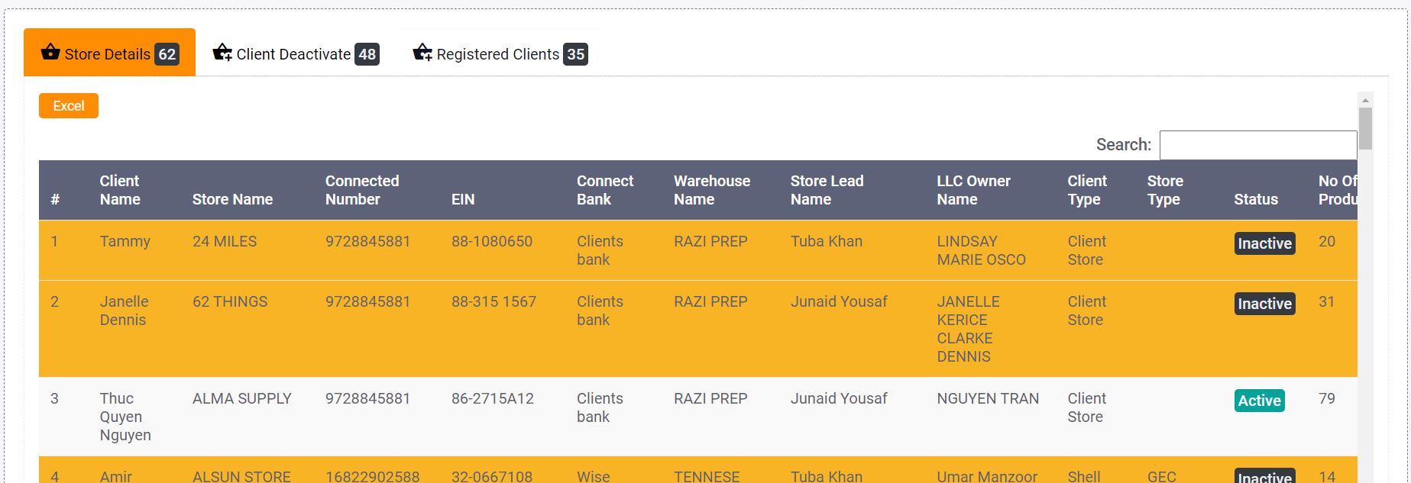

* Here , the column must display multiple store leads names to which the same store is assigned.